

PSHBS Enrollment Reconciliation Companion Guide

United States Office of Personnel Management

Created: March 18th, 2024
Version: 1.1

Revision History

Date | Version# | Description | Author
3/11/2024 | 1.0 | Initial Version (Draft) | Deloitte Consulting
3/18/2024 | 1.1 | Addressed the comments from OPM/HSA | Deloitte Consulting

Table of Contents
1. Introduction…………………………………………………………………………………………………………………..3
1.1 Guiding Principles……………………………………………………………………………………………….3
2. Monthly Reconciliation Methodology Overview…………………………………………………………….4
2.1 PSHBS Enrollment Snapshot & Carrier System-MENR Snapshot………………………….4
2.2 Receive Carrier’s MENR File………………………………………………………………………………..5
2.2.1 MENR File Format……………………………………………………………………………………………….6
2.2.2 MENR Extract File Transfer…………………………………………………………………………………7
2.2.3 MENR File Naming Convention…………………………………………………………………………....7
2.3 Reconciliation Process and Discrepancy File (Outbound Recon File - RCNO)……..8
2.3.1 RCNO File Format……………………………………………………………………………………………..12
2.3.2 RCNO Outbound Recon File - Extract Data Elements…………………………………………12
2.3.3 RCNO Extract File Transfer……………………………………………………………………………….12
2.3.4 RCNO File Naming Convention………………………………………………………………………….12
2.4 Discrepancy Review/Remediation……………………………………………………………………13
2.5 Carrier Review and Comments…………………………………………………………………………13

Introduction
This document contains the information necessary for Carriers and PSHB systems to conduct Enrollment Reconciliation Process periodically. Reconciliation is a streamlined approach whereby carriers must generate their member enrollment extracts (MENR Files) monthly and send them Inbound to PSHB system. The PSHB system then processes these MENR files, runs the reconciliation rules, creates the enrollment discrepancy files (RCNO Files) and provides instructions for carriers to remediate these discrepancies. This will help minimize operational issues related to enrollment discrepancies in both PSHB & Carrier Systems.
Defining rules for reconciliation, streamlining the process, and automating the discrepancy report will:
- Reduce the resource needs for performing manual reconciliation and mitigating each discrepancy.
- Expedite the timeline for each reconciliation cycle.
- Standardize discrepancy reporting.
This companion guide defines business rules and processes for reconciling enrollment data between carriers and the OPM PSHB System. Companion guides will evolve through collaborative efforts with the Carriers, and other participating entities within the PSHBS ecosystem.
Please note that this companion guide is a supplement to CL 2021-10. All information contained here aligns with CL 2021-10 and does not replace it.

Guiding Principles
The Monthly Reconciliation process shall be based on the following guiding principles:

- Carriers are expected to generate the member enrollment extract files (MENR) monthly as of 1st day of each month and securely transfer them to ROVR by the 3rd day of the month.
- The PSHB system will process the MENR files as part of the Reconciliation exercise and generate a discrepancy file (RCNO) for the enrollment differences between Carrier and PSHB systems.
- The MENR files from each carrier system should follow the consistent format and data field configurations (e.g., type, character length, etc.) in Carrier Letter 2021-10.
- Carriers will review the discrepancy reports and act as necessary (e.g., required
`changes, research warnings) to remediate the findings as appropriate.
- The discrepancy report will identify differences between the PSHBS and the carrier’s system, but in some cases, may still require resolution discussions.

The diagram below depicts a PSHBS Monthly Reconciliation Process:
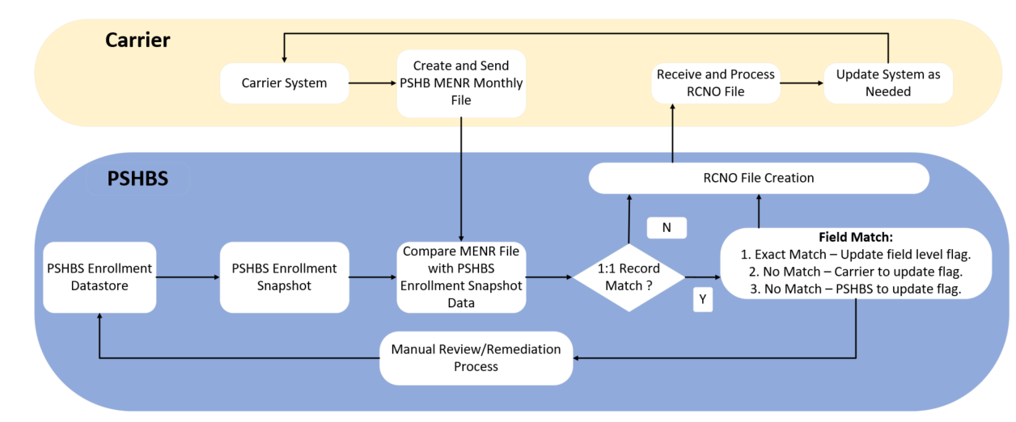

Monthly Reconciliation Methodology Overview

PSHBS Enrollment Snapshot & Carrier System-MENR Snapshot

The monthly reconciliation process starts with the PSHB System generating an Enrollment Snapshot and Carrier System generating MENR Snapshot on the 1st day of each month and store it in their respective data stores.

The following is the high-level timeline to streamline the monthly enrollment reconciliation procedure for both PSHB and Carrier Systems:

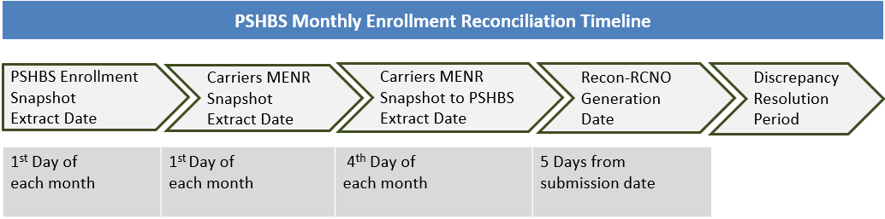

- Carriers must generate their MENR snapshots as of 1st day of each month and submit them by 3rd of the month.
- Enrollment snapshots from PSHBS & Carrier Systems must capture all Postal enrollments, as of the first of each month.

- The first MENR snapshots shall be generated as of 12/11/2024 and send them to PSHB system by 12/12/2024; this first snapshot will contain the enrollment records for Plan Year 2025
- However, from January-2025 onwards, the extract timeline shall follow as mentioned in the figure above for both Carrier and PSHB systems.
- The extract generation date must be captured by both systems for an accurate reconciliation and reconciliation purposes.

Receive Carrier’s MENR File

Below are guidelines for Carriers to generate their MENR extracts for successful acceptance of the file and a timely/accurate reconciliation. All guidelines are reiteration of information in CL 2021-10.

- All Carriers should follow the consistent MENR file format where the schema and data/field’s structure should align with the file layout specifications. Any deviations to the format will result in rejection of the MENR file and need for resubmission.

- The following table gives the subset of data elements from the MENR file used for the Reconciliation process.

Field Label | Description
LAST_NM | Member's last name. Left justified  Suffixes should not be included in the Member’s last name field.
FIRST_NM | Member's first name. Left justified.  Salutations should not be included in Member’s first name.  If a member has been born within the past year, the first name “NEWBORN” can be used. For multiple births, a numeral can be added after “NEWBORN” (i.e., “NEWBORN1”, “NEWBORN2”, etc.). First names indicating newborn status should not be used for Members over one-year-old.
BIRTH_DT | Member's date of birth. Format: YYYYMMDD.
MBR_SSN_NUM | Member's unique social security number.  If Member’s social security number is unknown or invalid, leave blank. Refer to SSA Guidance for process of identifying invalid social security numbers.
SUBSCR_SSN_NUM | Subscriber's social security number. This will be the same as the Member SSN for the Subscriber.  Subscriber social security number refers to the current policyholder.  Subscriber social security number is expected to be available for every Subscriber. If a Subscriber social security number is NOT available, then a Pseudo SSN (Field 41) should be provided.  In the very rare instances that a Subscriber’s social security number is unknown or invalid, leave blank. Refer to SSA Guidance for process of identifying invalid social security numbers.
PLAN_CD | 3-digit PSHB enrollment code. The same as CLER Reporting Field ENROLLMENT_CODE if reflecting current enrollment code, or previously reported enrollment code if reflecting a change in a prior record such as a termination.
COV_START_DT | Member’s coverage start date under the 3-digit FEHB or PSHB enrollment code reported in Field 16. Enrollment coverage start and end dates should only depend on Field 16 (FEHB or PSHB Enrollment Code) and should not reset at the beginning and end of each year automatically (i.e., if a member continues in the same plan option from one year to the next, Coverage Start Date and Coverage End Date should reflect continued enrollment). Format: YYYYMMDD
COV_END_DT | Member's coverage end date associated with enrollment code reported in Field 16. If a member is currently enrolled, leave blank or fill with date “9999-12-31”. If a member changes enrollment code within a plan, the Coverage End Date of the previous enrollment code should be one day prior to the Coverage Start Date of the next enrollment code.  Format: YYYYMMDD

MENR File Format
MENR file must comply with the requirements specified in the MENR structural layout, including data type, length, and mandatory/conditional fields as per Carrier Letter 2021-10.

MENR Extract File Transfer

Carriers to securely place their respective MENR files in the designated SFTP location per carrier letter 2021-10.

MENR File Naming Convention
File Type | Naming Format
MENR  Inbound File | PSHB_ATOZ_MENR_YYYYMMDD_YYYYMMDD_YYYYMMDD.TXT

        - The first and second date represent the beginning and end of the reporting period (month), while third date represents the date of transmission.

        - File type will be ASCII-encoded, pipe-delimited text file with no padded characters; one record per line.

Reconciliation Process and Discrepancy File (Outbound Recon File - RCNO)
PSHB system will perform the Enrollment Reconciliation by comparing the enrollment data from the Carriers MENR snapshots with the PSHB enrollment snapshot and generate an outbound file (RCNO) with the outcomes. This Outbound Enrollment Reconciliation File (RCNO) from PSHB system will contain the results for each member enrollment that is part of the Inbound MENR File.

Below are the steps outlining the Reconciliation process and guidelines for the Outbound Recon file (RCNO) for a timely, accurate and successful reconciliation.

- After processing the Carrier MENR file(s) successfully, the PSHB system will begin to establish a match between carrier enrollment records with PSHBS enrollment records by using the Member SSN, Member - First Name, Member - Last Name, and Member - Date of Birth elements to facilitate the efficient execution of the reconciliation process.

- The Reconciliation Report (RCNO) will be created by comparing the enrollment data from the Carriers MENR snapshots with the PSHB Enrollment snapshot.

- The Enrollment Reconciliation Report Outbound File (RCNO) is a pipe-delimited flat file.

- Following is the subset of the data elements submitted by the Carriers on the monthly enrollment snapshot (MENR) file which will be used in the reconciliation process and the same will be represented on the RCNO file with appropriate Record level or Field level flags to indicate the recon outcomes.

- The Record type (01) in this case denotes detailed records, hence it is associated with each of these data elements.

Record  Type | Field Label | Description
01 | LAST_NM | Member's last name.  Suffixes should not be included in the Member’s last name field.
01 | FIRST_NM | Member's first name. Left justified.  Salutations should not be included in Member’s first name.  If a member has been born within the past year, the first name “NEWBORN” can be used. For multiple births, a numeral can be added after “NEWBORN” (i.e., “NEWBORN1”, “NEWBORN2”, etc.). First names indicating newborn status should not be used for Members over one-year-old.
01 | BIRTH_DT | Member's date of birth. Format: YYYYMMDD.
01 | MBR_SSN_NUM | Member's unique social security number.  If Member’s social security number is unknown or invalid, leave blank. Refer to SSA Guidance for process of identifying invalid social security numbers.
01 | SUBSCR_SSN_NUM | Subscriber's social security number. This will be the same as the Member SSN for the Subscriber.  Subscriber social security number refers to the current policyholder.  Subscriber social security number is expected to be available for every Subscriber. If a Subscriber social security number is NOT available, then a Pseudo SSN (Field 41) should be provided.  In the very rare instances that a Subscriber’s social security number is unknown or invalid, leave blank. Refer to SSA Guidance for process of identifying invalid social security numbers.
01 | PLAN_CD | 3-digit PSHB enrollment code. The same as CLER Reporting Field ENROLLMENT_CODE if reflecting current enrollment code, or previously reported enrollment code if reflecting a change in a prior record such as a termination.
01 | COV_START_DT | Member’s coverage start date under the 3-digit FEHB or PSHB enrollment code reported in Field 16. Enrollment coverage start and end dates should only depend on Field 16 (FEHB or PSHB Enrollment Code) and should not reset at the beginning and end of each year automatically (i.e., if a member continues in the same plan option from one year to the next, Coverage Start Date and Coverage End Date should reflect continued enrollment). Format: YYYYMMDD
01 | COV_END_DT | Member's coverage end date associated with enrollment code reported in Field 16. If a member is currently enrolled, leave blank or fill with date “9999-12-31”. If a member changes enrollment code within a plan, the Coverage End Date of the previous enrollment code should be one day prior to the Coverage Start Date of the next enrollment code.  Format: YYYYMMDD

Record Level Match:

  - As an initial step, the PSHBS reconciliation process will attempt to establish the 1:1 record level match between carrier enrollment records with PSHBS enrollment records by using the ‘Member SSN’, ‘Member - First Name’, ‘Member - Last Name’, and ‘Member - Date of Birth’.

  - For a given Carrier enrollment record, if more than one enrollment record exists on PSHBS system, then system considers other elements, such as First Name, Last Name, DOB, SSN, Enrollment Coverage Start Date, Enrollment Coverage End Date and Current PSHB Enrollment Code to find the best match for each record and proceed with Reconciliation process.

  - Record-level reconciliation flags mentioned below will indicate outcome of record level matching –

S.no. | Record  Level Flag | Definition
1 | F | Unmatched PSHBS Record – No matching Carrier records  found
2 | I | Unmatched Carrier Record – No matching PSHB records  found
3 | M | Exact match – No action required
4 | N | 1:1 Record match with Carrier Action required – At least one  of more field flagged for carrier action
5 | Z | 1:1 Record match with PSHBS Action required – At least one  of more field flagged for PSHB action

Field Level Match:

  - Post completing the Record Level match, as a next step, PSHB system will perform the Field level matching for the records that has 1:1 match between both the system. i.e., When the outcome of the record level comparison results in M, N, Z then the system proceeds with Field level match process for rest of the elements and will include the outcomes in RCNO file.

  - Following are the field level reconciliation flags indicating the outcome of field level matches:

S.no. | Field Level  Flag | Definition
1 | M | Exact Match – No Action
2 | I | Non-Match – Carrier to update to PSHB value
3 | F | Non-Match – PSHB to update to Carrier value

- The RCNO file layout will also have the 02-record type elements indicating summary, in addition to the previously described 01-record type.
- 02 Record Type data elements provide a high-level summary at each plan code level as mentioned in the table below.
- It may not always be the case where the total enrollments for a given plan code yield a match between Carrier and PSHB System.

Record  Type | Field | Description
02 | PSHBS FILE PRCSS DT | Extraction Date of PSHBS Monthly Enrollment Snapshot.  Format: YYYYMMDD
02 | MENR FILE PRCSS DT | Extraction Date for MENR Monthly File. Format: YYYYMMDD
02 | PSHB PLAN CD | Unique value; containing first two digits of PSHB plan enrollment code.
02 | Total Count of Enrollments (PSHB Enrollment snapshot) | Total number of enrollments associated with the specific PSHB PLAN CD, captured in PSHB Enrollment snapshot.
02 | Total Count of Enrollments (Carrier MENR snapshot) | Total number of enrollments associated with the specific PSHB PLAN CD, captured in Carrier’s MENR snapshot.

RCNO File Format
As an outcome of the Reconciliation process, PSHB System generates monthly reconciliation enrollment outbound file (RCNO) as a pipe-delimited flat file.

The RCNO Structure layout is provided below. Each data element in the structural layout must adhere to the guidelines specified in the document.

RCNO Outbound Recon File - Extract Data Elements
RCNO Outbound Recon File will include the data elements mentioned in attachment provided as a sample file for Record and Field level outputs.

RCNO Extract File Transfer
PSHB System will securely place the Reconciliation Outbound file in the designated SFTP location from where Carriers can read and process.

RCNO File Naming Convention
The following is the proposed file format to be used to transfer the RCNO outbound file(s) to a carrier’s secure location.
File Type | Naming Format
RCNO  Outbound File | PSHB_ATOZ_RCNO_YYYYMMDD_YYYYMMDD_YYYYMMDD.TXT

        - The first and second date represent the beginning and end of the reporting period (month), while third date represents the date of transmission.

Discrepancy Review/Remediation
The PSHBS and Carrier Systems need to collectively devise the process to review the Reconciliation outcomes and remediation steps to ensure both the systems are in sync.

Carrier Review and Comments

The PSHBS System requests confirmation of the Carrier’s understanding of the Monthly Reconciliation process as defined and documented in this companion guide.

